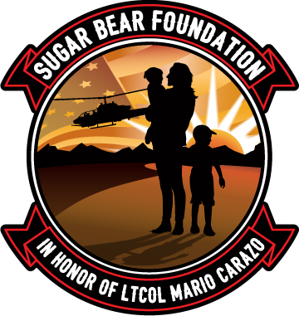

RF-Lambda Memorial Scholarship
In Honor Of
Lt. Colonel Mario "Sugar Bear" Carazo
To Apply, please send the following Required Documents to Admin@TheSugarBearFoundation.org (if not already on file):
- Sugar Bear Foundation Gold Star Registry Application
- Attach a copy of the DD1300 or other proof that you are receiving benefits due to your spouse’s or parent’s death from military service (PDF Files or legible photos are acceptable). You cannot move forward in this process without submitting your DD 1300 as well as signing the waiver.
- This Memorial Scholarship Application.
NOTE: If Scholarship is awarded, funds will be paid directly to the institution for such items as tuition, housing, fees or academic tutoring needs that pertain to selected coursework.

Name: Click or tap here to enter text.
Mailing Address: Click or tap here to enter text.

Phone number/s: Click or tap here to enter text.
Email: Click or tap here to enter text.
Parent or Guardians Name: Click or tap here to enter text.
Current School: Click or tap here to enter text.

1. Please forward an official transcript to the following address:
Sugar Bear Foundation
516 D River HWY #298
Mooresville, NC 28117

2. Please submit with your application, a letter of recommendation from either a teacher, coach, family friend, etc.

3. Please explain in an essay of 1000 words or less, how this scholarship would help you achieve your educational and future goals.

4. Please list any sports, clubs, volunteering or after school activities:
Click or tap here to enter text.

What are your career goals and how do you plan to achieve these goals?
Click or tap here to enter text.

What is the estimated Scholarship amount needed? Click or tap here to enter text.

Is there any other information that you believe is relevant to your application?
Click or tap here to enter text.

Please provide us with an anonymous statement (one to two sentences) that we can share with our donors and explain what this scholarship/grant means to you/your family? How does it help?

Click or tap here to enter text.

You must agree to the following terms to apply:
- All of the answers submitted are the applicant's original work.
- Neither you, nor any of your family members are related to anyone at the Sugar Bear Foundation or any employees at RF-Lambda.
- Your application, transcripts and information will be reviewed by members of the Sugar Bear Foundation and employees of RF-Lambda.
- You consent for us to contact any schools or references listed on this application.
- If selected, you must show proof of your relationship to the deceased service member.
- The scholarship is only awarded once and The Sugar Bear Foundation/RF-Lambda has the right to cancel for any reason and no reason.
- All of the information provided is to the best of your knowledge, is true and correct.
- The scholarship is open to any student who lost their parent during active military service. This includes KIA, accidents, suicide and illness. Payment of scholarship funds will be paid directly to the selected institution.
If you agree to these terms please sign:
Parent/Guardian: ____________________________________________
Student (Applicant): __________________________________________
Date: ___________________

